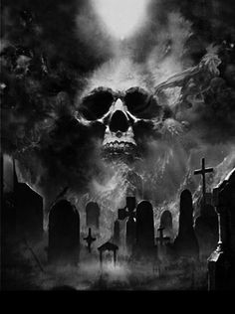

**THE SHORT-CUT**

A Film By Don J. Harper

Produced and directed By: Shadowcast pProuductions